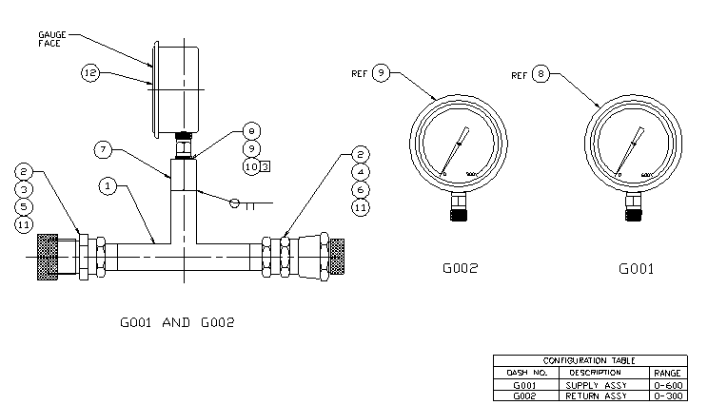
Part number 8039603G001 = $395. each
This can be used for both sides – no price available for G002 version.

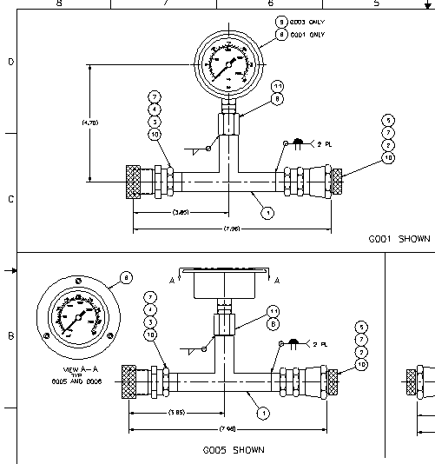
p/n 8039645G001 = $395. each
This can be used on both sides.
p/n 8039645G005 = $395. each
This can be used on both sides.

